Chapter 10, Solution 40.

Find i_{o} in the circuit shown in Fig. 10.85 using superposition.

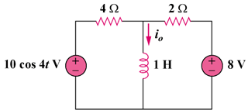

Figure 10.85
For Prob. 10.40.

Solution

Let I_{o} = I_{o1} + I_{o2}, where I_{o1} is due to the dc source and I_{o2} is due to the ac source. For I_{o1}, consider the circuit in Fig. (a).

8 V

2

4
+

I_{o1}

(a)
Clearly,
I_{o1} = 8/2 = 4 A

For I_{o2}, consider the circuit in Fig. (b).

2

4
+

I_{o2}

(b)

j4

100 V
If we transform the voltage source, we have the circuit in Fig. (c), where .
By the current division principle,

I_{o2}

(c)

j4

2.50 A

2

4
Thus,
Therefore,
I_{o} = I_{o1} + I_{o2} = [4 + 0.79cos(4t–71.56)] A

